**Question Bank**

**Networking and Communication Technologies**

**For Slow Bloomers:**

1. Which Protocol is used for the transfer of hypertext document on the internet?

Ans: HTTP ( or Hyper Text Transfer Protocol)

1. Two doctors in the same room have connected their Palm Tops using Bluetooth for working on a Group presentation. Out of the following, what kind of Network they have formed?

LAN, MAN, PAN, WAN

Ans : PAN

1. Arrange the following communication channels in ascending order of their data transmission rates.

Ethernet Cable, Optical Fiber, Telephone Cable, Co-axial Cable?

Ans: Telephone Cable, Ethernet Cable, Co-axial Cable, Optical Fiber

1. Jai Khanna is confused between the terms Domain Name and URL. Explain the difference with the help of appropriate examples of each.

Ans: A URL (Uniform Resource Locator) is the complete address of a document on the web, whereas a domain name specifies the location of document's web server. A domain name is a component of the URL used to access web sites. For example the web address

<http://www.example.net/index.html> is a URL. In this URL www.example.net is the domain name.

1. Define any two threats to Network Security.

Ans: **Denial of Service:** It refers to any threat that prevents the legitimate users from accessing the network resources or processing capabilities.

**Snooping:** It refers to any threat that results in an unauthorized user obtaining information about a network or the traffic over that network.

1. What do you mean by a computer network?

Ans:- Computer network is an interconnection of autonomous computers connected together using transmission media.

1. What is the need for networking the computers?

Ans:- 1. Sharing of Information,

2. Reliability

3. Reduces cost

4. Time saving

1. What is the full form of ARPANET?

Ans:- Advanced Research Projects Agency Network

1. What are various data transmission modes?

Ans:- There are three modes of data transmission

* Simplex
* Half-duplex
* Full-duplex

1. What is the difference between Simplex and half duplex transmission?

Ans:- In simples transmission mode, the data can be transferred in only one direction where as in half duplex transmission mode, the data can be transmitted in both directions but one at a time.

1. What do you mean by MODEM?

Ans:- MODEM stands for MODulatorDEModuator. It is a device that can convert an analog signal into digital signal and vice versa.

1. Define the terms Bandwidth.

Ans:- Bandwidth is the range of frequencies that is available for the transmission of data. Wider the bandwidth of a communication channel, the more data it can transmit in a given period of time.

1. What are various types of transmission media?

Ans:- There are two broad categories of transmission media

* Guided media
* Unguided Media

1. Explain in brief the advantages and disadvantages of Twisted pair Cable.

Ans:- Advantages

* Inexpensive
* Often available in existing phone system
* Well tested and east to get

Disadvantages

* Susceptible to noise (sound, energy etc.)
* Not as durable as coaxial cable
* Does not support high speed

1. What do you mean by communication protocol?

Ans:- A protocol is a set of rules to enable computers to connect with one another and to exchange information with minimum possible error.

**For Average Students:**

1. List various functions of Communication protocol.

Ans:- Data sequencing, Data Formatting, Flow control, Error Control,Connection Establishment and termination,Data Security

1. List commonly used protocols.

Ans:- HTTP, TCT/IP, FTP, SLIP, PPP, SMTP, POP, ICMP

1. What are the main functions of TCP

Ans:- The TCP does the following activities

* It breaks the data into packets that the network
* Verifies that all the packets arrived at the destination
* Reassembles the data

1. What do you mean by network topology?

Ans:- Topology is how the nodes/computers are interconnected together.

1. List various types of Networks.

Ans:- LAN, MAN, WAN

1. Give names of various networking topologies in LAN.

Ans:- 1.Star Topology

2.Ring topology

3.Bus topology

4.Mesh Topology

1. Write two advantages and two disadvantages of STAR topology.

Ans:- Advantages of STAR topology

* It is easy to modify and add new computers to a star network without disturbing the rest of the network.
* Troubleshooting a star topology network is easy

Disadvantages

* All the nodes are dependent on the central system. Hub. Failure of hub result in shutting down of whole of the system
* Long cable length is required

1. What is NFS?

Ans:- NFS stands for Network File System. NFS is a protocol that allows a set of computers to access each others files.

1. Differentiate between Star and Bus Topology of networks.

Ans: **Star Topology:** It is characterized by central switching node (communication

controller) and unique path (point to point link) for each host. It is easy to add and

remove hosts easily.

**Bus Topology**: It is characterized by common transmission medium shared by all the connected hosts, managed by dedicated nodes. It offers simultaneous flow of data and

control.

1. Define a network.

Ans : A computer network is a system in which computers are connected to share

information and resources.

1. Write two advantages of networks.

Ans. : Advantages:

I. Data or information can be shared among the users.

ii. Fast communication can be achieved.

iii. Expensive hardware or software can be shared among the users.

1. Write two disadvantages of networks.

Ans: Disadvantages of networks:

i. Sophisticated Hardware and software technology is required.

ii. Expensive to install network.

iii. Threat to security of data and information.

1. What is MAC Address?

Ans: In computer networking, a **Media Access Control address** (MAC address) is a unique identifier assigned to most network adapters or network interface cards (NICs) by the manufacturer for identification, and used in the Media Access Control protocol sub-layer.

1. What is IP address?

Ans: A unique number consisting of 4 parts separated by dots, e.g. 165.113.245.2

Every machine that is on the Internet has a unique IP number - if a machine does not have an IP number, it is not really on the Internet.

1. What is domain name? How is it alternatively known?

Ans: The unique name that identifies an Internet site. Domain Names always have 2 or more parts, separated by dots. The part on the left is the most specific, and the part on the right is the most general. E.g.: matisse.net

1. What are the various types of networks?

Ans 8: Network can be classified on the basis of their size, complexity and geographical

spread. On the basis of geographical spread it can be classified as Local Area Network,

Metropolitan Area Network and Wide Area Network.

1. What is the difference between MAN and WAN?

Ans. 9: A **metropolitan area network** (**MAN**) is a large computer network that usually

spans a city or a large campus.

WAN is a *network* that covers an area larger than a single building or campus such as across the cities or countries.

1. What is protocol? How many types of protocols are there?

Ans. When computers communicate each other, there needs to be a common set of rules and instructions that each computer follows. A specific set of communication rules is called a protocol. Some protocol: PPP, HTTP, SLIP, FTP, TCP/IP

1. What is the difference between Networking and Remote Networking?

Ans. The main difference between Networking and Remote Networking, is the network which we use in offices or other places locally such LAN or INTERNET and remote networking is one which we use TERMINAL Services to communicate with the remote users such WAN.

1. What is meant by Topology? Name some popular topologies.

Ans: **Network topology** is defined as the interconnection of the various elements (links, nodes, etc.) of a computer network. In computer networking, topology refers to the layout of connected devices.

• Bus topology

• Star topology

• Ring topology

• Tree topology

• Mesh topology

1. What are the factors that must be considered before making a choice for the topology?

Ans: Cost of Expenses required for implementation of network, Reliability of a particular topology and flexibility of system for future adjustment; are the various factors that must be considered before making a choice for the topology.

1. What are the similarities and differences between bus and tree topologies?

Ans: In bus topology each machine is connected to a single cable. Each computer or server is connected to the single bus cable through some kind of connector.

Tree topology is a network with the shape of an inverted tree in which a single link between two nodes.

1. What are the limitations of star topology?

Ans: i. Central node dependency: In this topology central node is a controller of the network. If the central node fails, the entire network will be failed.

ii. Difficult to expand: The addition of a new node to a network involves a connection all the way to the central node.

1. When do you think, ring topology becomes the best choice for a network?

Ans: In case if we need less connection of wires, very fast communication speed; a ring topology becomes the best choice for a network. This is because optical fiber offers the possibility of very high seed transmissions in one direction.

1. Write the two advantages and two disadvantages of star topology in network.

Ans: i. The star topology is considered the easiest topology to design and implement.

ii. An advantage of the star topology is the simplicity of adding additional nodes.

1. Write the disadvantages if twisted pair cables.

Ans: i. A twisted pair cable is incapable carrying a signal over long distances without the use of repeaters.

ii. Its low bandwidth capabilities are unsuitable for broadband applications.

iii. Its supports maximum data rates 1mbps without conditioning and 10 mbps with

conditioning.

1. Define Hub.

Ans : The central connecting device in a computer network is known as a hub. When data packets arrives at hub, it broadcast them to all the LAN cards in a network and the destined recipient picks them and all other computers discard the data packets.

1. Define switch.

Ans: A Switch is a device that is used to segment networks into different sub networks called subnets or LAN segments. Segmenting the network into smaller subnets, prevents traffic overloading in a network.

1. What are the goals of network?

Ans:. Goals of network:

􀂃 **Resource sharing**: The aim to make all programs, data and peripherals available to anyone on the network irrespective of the physical location of the resources and the users.

􀂃 **Reliability**: A file can have copies on two or more machines, so if one of them is unavailable due to hardware or software crash, the other copies could be used. E.g.: Railway reservation, Airways reservation etc.

􀂃 **Cost Factor**: Personal computers have better price / performance ratio as the important data are stored on file server machine available for sharing.

􀂃 **Communication Medium**: Using a network, it is possible for managers, working far apart, to prepare financial report of the company. The changes at one end can be immediately noticed at another and hence it speeds up co-operation among them.

1. Write the applications of network?

Ans: Application of networks:

1. Sharing Computer peripherals among the connected users.

2. Sharing Data or information among the connected users.

3. Access to remote database: User can access to remote database sitting at his home to make reservation for airplanes, trains hotels and so on anywhere in the world with instant confirmation.

4. Communication facilities: Using Network, user can share text, images, digitized voice or movie to any users anywhere in the world.

5. Cost deduction: Using Computer Network communication system, amount required for travelling of user or data from one location to another can be reduced to very less and also saves energy for the same.

1. What do you understand by domain name resolution?

Ans: Domain Name Resolution is the task of converting domain names to their corresponding IP address. This is all done behind the scenes and is rarely noticed by the user. When you enter a domain name in an application that uses the Internet, the application will issue a command to have the operating system convert the domain name into its IP address, and then connect to that IP address to perform whatever operation it is trying to do.

1. What are communication channels? Discuss various channels available for networks?

Ans: Communication channels mean the connecting cables that link various workstations. There are 3 basic types of cables:

* Twisted Pair cables
* Coaxial cables
* Fiber-optic cables

Coaxial Cables: A cable consisting of two concentric conductors (an inner conductor and an outer conductor) insulated from each other by a dielectric; commonly used for the transmission of high-speed electronic data and/or video signals.

Fiber Optic Cables: It is flexible optically transparent fiber, usually made of glass or plastic, through which light can be transmitted by successive internal reflections.

Twisted Pair: A cable composed of two small insulated conductors twisted together without a common covering. Also known as copper pair. Twisted pairs have less bandwidth than coaxial cable or optical fiber.

33. Advantages and disadvantages of the followings :

i. optic fiber

ii. coaxial cables

iii. twisted pair cables

iv. radio waves

v. microwaves

vi. Satellites

Ans (i): **Optic fiber**:

Advantage:

i. It is free from electrical noise and interference

ii.It has more bandwidth than copper wire.

Disadvantage: It is an expensive communication medium.

(ii) **Coaxial cables:**

Advantage :

1. It provides a cheap means of transporting multi-channel television signals around metropolitan areas.

Disadvantage: Expensive than twisted pair cables.

(iii) **Twisted pair cables:**

Advantage:

It is inexpensive.

It is easy to install and maintain.

Disadvantage:

It has low bandwidth capabilities.

It is unsuitable for broadband connection.

(iv) **Radio Wave:** A data transmission by use of radio frequencies is called as radio-wave transmission.

Advantages:

i. Radio waves transmission offers mobility.

ii. It proves as cheaper communication system.

iii. It offers ease communication over difficult terrain.

Disadvantages:

i. It is an insecure communication system.

ii. Radio Signals are susceptible to weather condition like thunder storms, rains etc.

(v): A **microwave communication system** is a communications system that uses a beam of radio waves in the microwave frequency range to transmit video, audio, or data between two locations, which can be from just a few feet or meters to several miles or kilometers apart. Microwave links are commonly used by television broadcasters to transmit programmes across a country, or from an outside broadcast back to a studio.

Advantage:

i. It is cheaper communication system

ii. . It offers ease communication over difficult terrain.

iii. It offers ease communication over oceans.

Disadvantage:

i. It is an insecure communication system.

ii. Radio Signals are susceptible to weather condition like thunder storms, rains etc.

iii. Signals from single antenna may split up and propagate in slightly different path and hence reduces the signal strength.

1. Discuss and compare various types of networks?

**Ans: Network topology** is defined as the interconnection of the various elements (links, nodes, etc.) of a computer network. In computer networking, topology refers to the layout of connected devices.

o Bus topology

o Star topology

o Ring topology

o Tree topology

o Mesh topology

1. Explain mostly used topologies.

Ans: Star topology is widely use due to following reasons:

i. The star topology is considered the easiest topology to design and implement.

ii. An advantage of the star topology is the simplicity of adding additional nodes.

1. What are hubs? What are its types?

Ans: A hub is hardware device used to connect several computers together. It is of two types Active or passive Hubs. Active hub is one which amplifies the signal as it moves from one connected device to another. Passive hub allows the signal to pass from one computer to another computer without any change.

1. What is the role of a switch in a network?

Ans: A Switch is a device that is used to segment networks into different sub networks called subnets or LAN segments. Segmenting the network into smaller subnets, prevents traffic overloading in a network. A switch is responsible for filtering i.e. transforming data in a specific way and for forwarding packets (a piece of message) between LAN segments. Switch support any packet protocol. LANs that are segmented through switches are called switched LANs.

1. Discuss repeater.

Ans: Repeater is a device used in data communication to strengthen a signal as it is passed along the network cable. There are two types of Repeater:

Amplifier: It amplifies all incoming signals as well as concurrent noise.

Repeater: It regenerates the packet as if it is starting from the source station.

1. What are common threats to network security?

Ans: The various threats to network security are as follows:

1. Intrusion Problems / Access Attacks: This occurs when an unauthorized user attempts to protected sensitive / confidential information. It may be of following types:

c. **Snooping:** It refers to unauthorized access to someone else’s data, email or computer activity.

d. **Eavesdropping**: It refers to unauthorized listening / intercepting someone else’s private communication / data/ information.

2. **Denial-of-services attacks**: DoS are those attacks that prevent the legal users of System from accessing or using the resources, information or capabilities of the system. It may be of following types :

a. **Denial of Access to Information**: Such attacks causes deletion or changing of important information to non readable format.

b. **Denial of Access to Applications**: Such attacks makes the applications unusable or unavailable for legal user of the system.

c. **Denial of Access to Communications**: Such attacks includes cutting of communication wire, jamming radio communications, flooding a system with junk mail.

1. What are denial of services attacks?

Ans: **Denial-of-services attacks**: DoS are those attacks that prevent the legal users of System from accessing or using the resources, information or capabilities of the system. It may be of following types:

􀂃 **Denial of Access to Information**: Such attacks cause deletion or changing of important information to non readable format.

􀂃 **Denial of Access to Applications**: Such attacks make the applications unusable or unavailable for legal user of the system.

􀂃 **Denial of Access to Communications**: Such attacks includes cutting of communication wire, jamming radio communications, flooding a system with junk mail.

1. How can you prevent/ counter threats of network security?

Ans: Threats of network security can be prevented by using various techniques:

i. **Authorization**: In this case User is asked to enter an authorized login-id. If user is able to provide legal login-id then he/she is considered as authorized user.

ii. **Authentication**: In this case User is asked to enter a legal password. If user is able to provide legal password then he/she is considered as authenticate user.

iii. **Firewall** : Firewall is a mechanism to prevent unauthorized internet user to access private network connected to internet.

iv. **Intrusion Detection**: This is a monitoring system which detects unauthorized access of data or resources of the network.

**For Bright Students:**

**Tips to solve Questions based on Networking**

1. **Where Server should be placed**: Server should be placed in the building where the number of

computers is **maximum**.

2. **Suggest a suitable cable layout of connection**: A suitable cable layout can be suggested in the

following two ways:-

**(i) On the Basis of Server:** First the location of the Server is found out. Server is placed in that building

where the number of computers are maximum (According to 80 – 20 rule). After finding the server

position, each building distance is compared with the Server building directly or indirectly (taking other

building in between). The shortest distance is counted whether it is through directly or indirectly.

**(ii) On the Basis of Distance from each building:** The distance between the each building is compared to

all other buildings either directly or indirectly. The shortest distance is counted whether it is directly or

through some other building.

3. **Where the following devices be placed**:

(i) **MODEM**:-

(ii) **HUB** / **SWITCH:- In all the wings**

(iii) **BRIDGE**:

(iv) **REPEATER**: It is used if the distances higher than 70 m. It regenerates data and voice signals.

(v) **ROUTER**: When one LAN will be connected to the other LAN.

Ques 1. Knowledge Supplement Organisation has set up its new center at Mangalore for its office and web based activities. It has 4 blocks of buildings as shown in the diagram below:



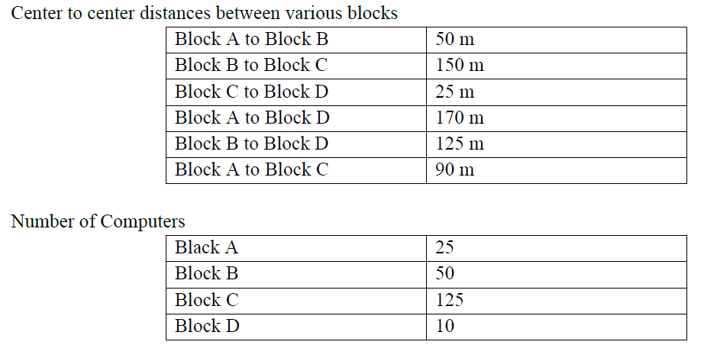

* Suggest a cable layout of connections between the blocks.
* Suggest the most suitable place (i.e. block) to house the server of organisation with a suitable reason.
* Suggest the placement of the following devices with justification
  + Repeater
  + Hub/Switch
* The organization is planning to link its front office situated in the city in a hilly region where cable connection is not feasible, suggest an economic way to connect it with reasonably high speed?

Ans: (Any of the following option)

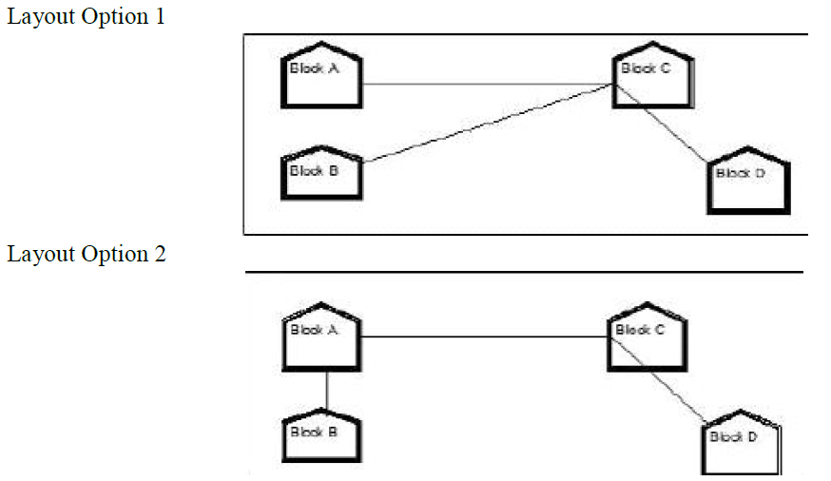

(2) The most suitable place / block to house the server of this organisation would be Block C, as this block contains the maximum number of computers, thus decreasing the cabling cost for most of the computers as well as increasing the efficiency of the maximum computers in the network.

(3) (i) For Layout 1, since the cabling distance between Blocks A and C, and that between B and C are quite large, so a repeater each, would ideally be needed along their path to avoid loss of signals during the course of data flow in these routes. For layout 2, since the distance between Blocks A and C is large so a 124 repeater would ideally be placed in between this path.

(ii) In both the layouts, a hub/switch each would be needed in all the blocks, to interconnect the group of cables from the different computers in each block.

(4) The most economic way to connect it with a reasonable high speed would be to use radio wave transmission, as they are easy to install, can travel long distances, and penetrate buildings easily, so they are widely used for communication, both indoors and outdoors. Radio waves also have the advantage of being omni directional, which is they can travel in all the directions from the source, so that the transmitter and receiver do not have to be carefully aligned physically.

Ques2: 2. Ravya Industries has set up its new center at Kaka Nagar for its office and web based activities. The company compound has 4 buildings as shown in the diagram below:



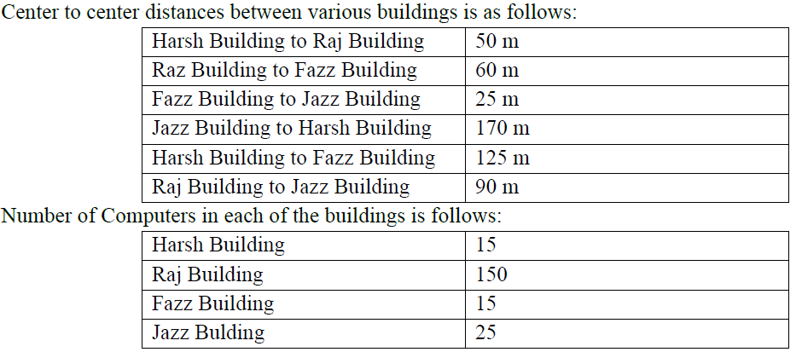

e1) Suggest a cable layout of connections between the buildings.

e2) Suggest the most suitable place (i.e. building) to house the server of this organisation with a suitable reason.

e3) Suggest the placement of the following devices with justification:

(i) Internet Connecting Device/Modem

(ii) Switch

e4) The organisation is planning to link its sale counter situated in various parts of the same city, which type of network out of LAN, MAN or WAN will be formed? Justify your answer.

Ans:

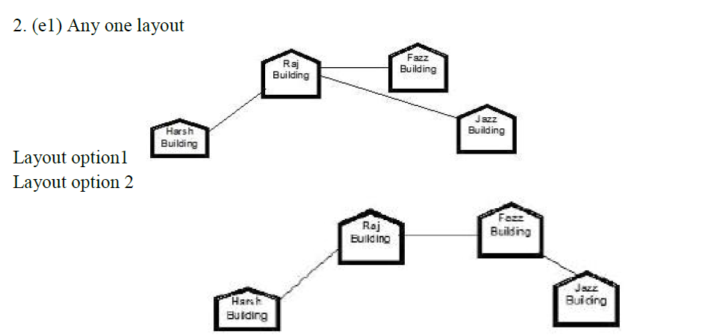

(e2) The most suitable place / block to house the server of this organisation would be Raj Building, as this block contains the maximum number of computers, thus decreasing the cabling cost for most of the computers as well as increasing the efficiency of the maximum computers in the network.

(e3)(i) Raj Building

(ii) In both the layouts, a hub/switch each would be needed in all the buildings, to interconnect the group of cables from the different computers in each block e4) MAN, because MAN (Metropolitan Area Networks) are the networks that link computer facilities within a city.

3. “China Middleton Fashion” is planning to expand their network in India, starting with two cities in India to provide infrastructure for distribution of their product. The company has planned to set up their main office units in Chennai at three locations and have named their offices as “Production Unit”, “Finance Unit” and “Media Unit”. The company has its corporate unit in New Delhi.

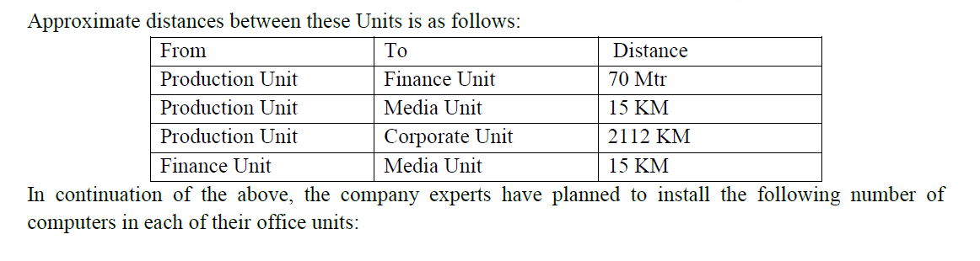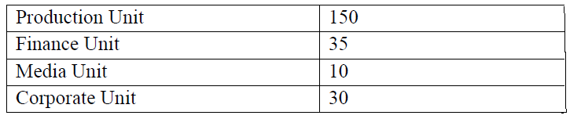i) Suggest the kind of network required (out of LAN,MAN,WAN) for connecting each of the following office units:

• Production Unit and Media Unit

• Production Unit and Finance Unit

ii) Which one of the following devices will you suggest for connecting all the computers within each of their office units?

• Switch/Hub

• Modem

• Telephone

iii) Which of the following communication media, will you suggest to be procured by the company for connecting their local offices in Chennai for very effective (High Speed) communication?

• Ethernet cable

• Optical fiber

• Telephone cable

(iv) Suggest a cable/wiring layout for connecting the company’s local office units located in Chennai. Also, suggest an effective method/technology for connecting the company’s office unit located in Delhi.

ANS:

3. (i)(a) Production Unit and Media Unit :MAN

(b)Production Unit and Finance Unit:LAN

(ii) Switch/Hub

(iii) Optical fiber

(iv) Optical Fiber/Star Topology Wireless/Satellite Link/Leased Line

4. What is point-to-point protocol?

Ans. A communication protocol used to connect computer to remote networking services include Internet Service Providers. In networking, the Point-to-Point protocol is commonly used to establish a direct connection between two nodes. Its primary use has been to connect computers using a phone line.

5. How gateway is different from router?

Ans. A gateway operates at the upper levels of the OSI model and translates information between two completely different network architectures. Routers allow different networks to communicate with each other. They forward packets from one network to another based on network layer information. A gateway can interpret and translate the different protocols that are used on two distinct networks. Unlike routers that successfully connect networks with protocols that are similar, a gateway perform an application layer conversion of information from one protocol stack to another.

6. What is the role of network administrator?

Ans. Basic tasks for which a network administrator may be responsible:

• Setting up and configuring network hardware and software.

• Installing and configuring network media and connections.

• Connecting user nodes and peripherals of all kinds to the network.

• Adding users to and removing users from the network.

• Managing user account.

• Ensuring the security of the network.

• Provide training to the users to utilize the network’s resources.

7. What is the difference between baseband and broadband transmission?

Ans. Baseband is a bi-directional transmission while broadband is a unidirectional transmission. No Frequency division multiplexing possible in base band but possible in broadband.

SNo Baseband Broadband

1 Entire bandwidth of the cable is consumed by a signal broadband transmission, signals are sent on multiple frequencies, allowing multiple signals to be sent simultaneously.

2 Digital signals Analog signals

3 bi-directional transmission unidirectional transmission

4 No Frequency division multiplexing possible Frequency division multiplexing possible

5 Uses for short distance Uses for long distance

8. What are the difference between domain and workgroup?

Ans.

SNo Domain Workgroup

1. One or more computers are servers All Computers are peers.

2. If you have a user account on the domain, you can logon to any computer on the domain. Each computer has a set of accounts.

3. There can be 100+ computers Typically not more then 20-30 computers

4. The computers can be on different local network All computers must be on the same local netork.

9. What is the differences between POP3 and IMAP Mail Server?

Ans. IMAP is a standard protocol for accessing e-mail from a local server. A simpler e-mail protocol is Post Office Protocol 3 (POP3), which download mail to the computer and does not maintain the mail on the server. IMAP, e-mails are stored on the server, while in POP3, the messages are transferred to the client’s computer when they are read.

10. Name different layer of the ISO OSI Model.

Ans. International Standard Orrganisation – Open Systems Interconnection has seven layers; Physical Layer,Data Link Layer,Network Layer,Transport Layer,Session Layer,Presentation Layer Application Layer

11. What is client server architecture?

Ans. To designated a particular node which is well known and fixed address, to provide a service to the network as a whole. The node providing the service is known as the server and the nodes that use that services are called clients of that server. This type of network is called Client-Server Architecture.

12. What is FDM? Give example.

Ans. FDM-Frequency Division Multiplexing is used in analog transmission. It is often used in short distance. It is code transparent and any terminal of the same speed can use the same sub-channel after the sub-channel is established. The best example if FDM is the way we receive various stations in a radio.

13. Describe the following in brief:

i) MOSAIC ii) USENET iii) WAIS

Ans. i) MOSAIC: is the program for cruising the internet. The National centre wrote this program for Super Computer application at the university of Illinois. It has a simple window interface, which creates useful hypertext links that automatically perform some of the menu bar and button functions.

ii) USENET: is the way to meet people and share information. Usenet newsgroup is a special group set up by people who want to share common interests ranging from current topic to cultural heritages.

iii) WAIS: is a WIDE AREA INFORMATION SERVER.